Vi Editor - Assignments
- Invoke the vi editor with a filename (which is to be created)
Ans:- vi sample
- Type a few lines(at least 10) in the editor. Let one or more lines contain the words given below.
delhi mumbai chennai Mumbai
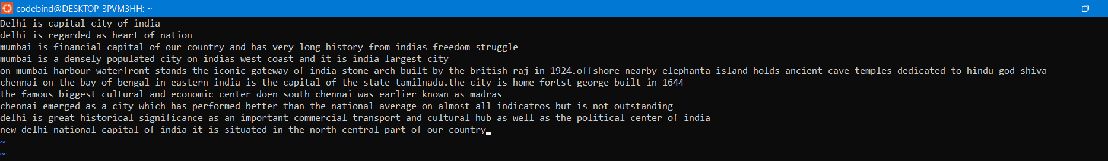

- Save the file without exiting the editor
Ans:- :w
- Navigate quickly to the beginning & end of the file
Ans:- gg and G.
- Delete first two lines & copy it after the last line.
Ans:- 2dd - delete first two, G-go to last line, $-to go to end of last line , p-paste after the cursor
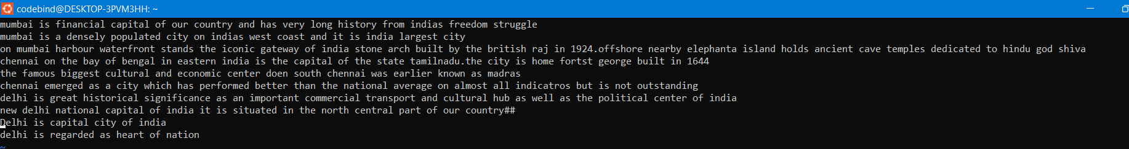
- Now Copy the last two lines & paste them before the first line.
Ans:- yy-to copy last two lines from the cursor, g-go to first line, P-paste it before cursor
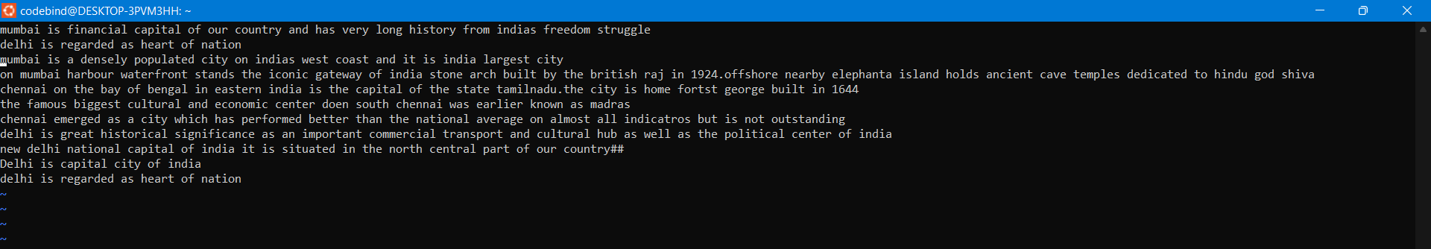
- Combine last two lines of the file in a single line.
Ans:- J
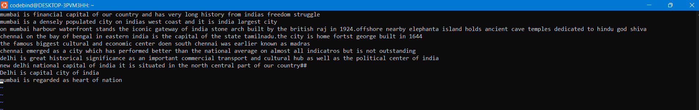
- How will you insert a line before the first line? (Hint : Find such an option in the tutorial document)
Ans:- i
- How will you paste a yanked buffer before the current line?
Ans:-p
- Search the document for a string “delhi”
Ans:- /delhi
- Replace a single occurrence of “delhi” with “Mumbai”
Ans:- :s/delhi/Mumbai
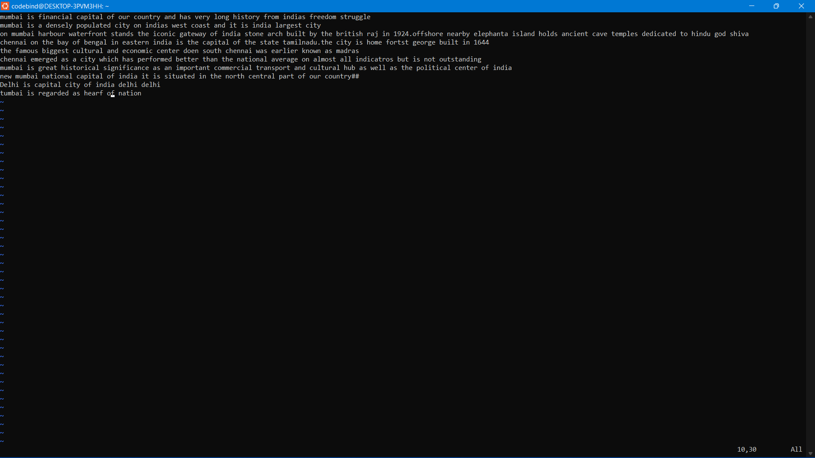
- Replace all occurrences of “delhi” on a particular line with “Mumbai” using one command
Ans:- :s/delhi/Mumbai/g
- Replace “delhi” with “mumbai” for the entire document using one command.
Ans:- %s/delhi/Mumbai/g
- Replace all occurrences of “delhi” with “mumbai” for part of a document (e.g. line number 13 to 37).
Ans:- 2-8 lines :2,8s/delhi/Mumbai/g
- Undo the above command
Ans: u
- Replace only the first occurrence of “delhi” with “mumbai” in each line, for part of a document (e.g. line number 13 to 37).
Ans: 2,8s/delhi/Mumbai/g
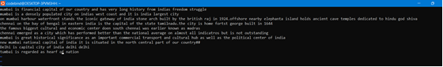
- Undo the above comment. Redo it. Undo it again
Ans: u cntrl+R u
- Replace all occurrences of “delhi” with “mumbai” for complete file interactively.
Ans:- %s/delhi/Mumbai/gc and a
- Search for a word backwards. Loop through all matches.
Ans: /delhi
- Search for a word forwards. Loop through all matches:
Ans: ?delhi
- Join two lines together.
Ans: :J

- Enable line numbering and then disable it
Ans: set number
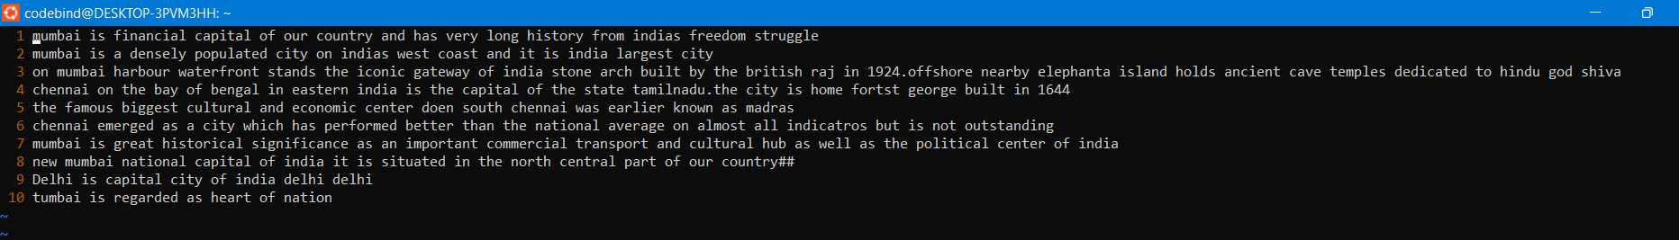
- Make the search case insensitive
Ans: :set noic
- Delete 4 lines (and then paste them somewhere else)
Ans: 4dd and p
- What is the command to delete part of the line starting from the current cursor position?
Ans: ?D
- What is the command to delete the current word?
Ans: ?dw

